**Money Module**

**Use Case Descriptions**

|  |  |  |  |
| --- | --- | --- | --- |
| **Use Case Name** | **Create an income transaction** | | |
| Triggering Event | Money coming into the business. | | |
| Brief Description | Allows the Owner to record an income transaction. | | |
| Actors | Owner | | |
| Related Use Cases |  | | |
| Preconditions | Owner has opened the Main Menu. | | |
| Post Conditions | Income transaction is saved and added to financial totals. | | |
| Flow of activities | Actor | | System |
|  |  | Requests to add a new income transaction | Displays a calendar  Prompts for description, transaction amount and HST amount  Displays a list of payment types and prompts for selection |
|  |  | Selects the transaction Date  Selects the payment  Enters the transaction description  Enters the transaction amount | Verifies that date is selected  Verifies that description and amount have been entered  Verifies that the payment type was selected.  Calculates HST  Displays income transaction  Prompts to save |
|  |  | Request to save | Saves the transaction and returns to the main menu |
| Exception Conditions | * Owner chooses to cancel adding the transaction | | |

Create an income transaction

|  |  |  |  |
| --- | --- | --- | --- |
| **Use Case Name** | **Create an expense transaction** | | |
| Triggering Event | Money leaving the business. | | |
| Brief Description | Allows the Owner to record an expense transaction. | | |
| Actors | Owner | | |
| Related Use Cases |  | | |
| Preconditions | Owner has opened the Main Menu. | | |
| Post Conditions | Expense transaction is saved and added to financial totals. | | |
| Flow of activities | Actor | | System |
|  |  | Requests to add a new expense transaction | Displays a calendar  Prompts for description, transaction amount and HST amount |
|  |  | Selects the transaction Date  Enters the transaction description  Enters the transaction amount | Verifies that date is selected  Verifies that description and amount have been entered  Calculates HST  Displays financial transaction  Prompts to save |
|  |  | Request to save | Saves the transaction and returns to the main menu |
| Exception Conditions | * Owner chooses to cancel adding the transaction | | |

Create an expense transaction

|  |  |  |  |
| --- | --- | --- | --- |
| **Use Case Name** | **Query Financial Transaction** | | |
| Triggering Event | Owner requires a list of transactions for a date period including Total Income, Total Expenses, Total Profit, Total HST collected, Total HST Paid, HST Owed | | |
| Brief Description | Allows the Owner to retrieve financial totals for a specified date range | | |
| Actors | Owner | | |
| Related Use Cases |  | | |
| Preconditions | Owner has opened the Main Menu. | | |
| Post Conditions | Financial transactions are retrieved, totaled and displayed | | |
| Flow of activities | Actor | | System |
|  | 1. | Requests to query financial transactions | Displays a calendar |
|  | 2. | Selects date range | Verifies that dates are selected  Retrieves transactions in the specified date range  Calculates and displays total income, total expenses, Profit, total HST Owed. Prompts to exit |
|  | 3. | Request to exit | returns to the main menu |
| Exception Conditions |  | | |

Query Financial Transaction

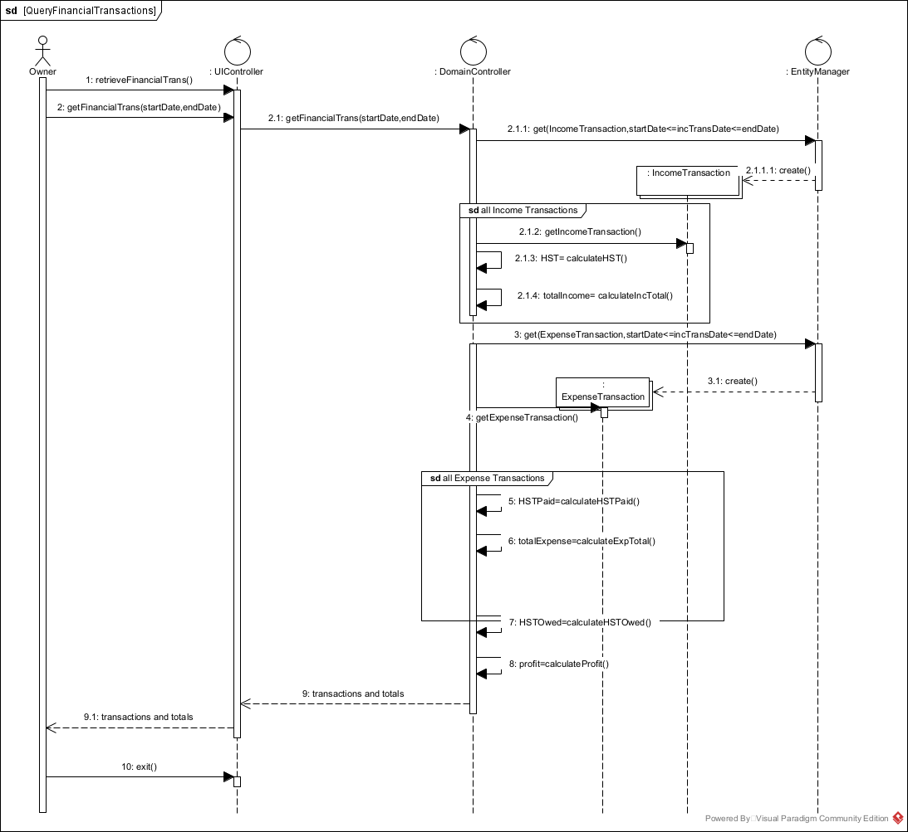

PaymentType.h

public class PaymentTye {

int paymentTypeId;

String paymentTypeDesc;

}

ExpenseTransaction.h

public class ExpenseTransaction {

int expTransID;

String expTransDesc;

int expTransDate;

double expTransAmount;

String expTransReceipt;

getExpTrans() {// gets Expense transaction data}

create() {// instantiates objects }

}

IncomeTransaction.h

public class IncomeTransaction {

int incTransID;

PaymentType paymentType;

String incTransDesc;

int incTransDate;

double incTransAmount;

String incTransReceipt;

getIncTrans() {// gets income transaction data}

}

UIController.h

public class getPaymentTypes() {

// allows the user to request payment types

// passes message to the Domain Controller

// displays list of payment types to the user

}

public class enterIncomeTrans(transDate,inceSrc,transAmount,transDesc) {

// passes entered data to the domain controller

// displays income transaction

}

public class confirm() { // saves }

createNewExpTrans() {

// prompts for expense transaction

{

public class enterExpTrans(exptransDate, exptransAmount,exptransDesc) {

// passes entered data to the domain controller

// displays expense transaction

}

public class saveTransaction () {

// sends request to domain controller to save

}

public class retrieveFinancialTrans () {

// displays a calendar and prompts for date range selection

}

public class getFinancialTrans(startDate, endDate) {

// passes request for financial transactions to the domain controller

// display transactions and totals

}

public class exit() {

// exits application

}

DomainController.h

public class getPaymentTypes() {

// requests payment types from the entity manger

// retrieves payment types data and returns to the UIController

}

public class createInconeTrans(transdate,paymentTypeID,transAmount,transDesc) {

// sends request to create a new income transaction

// receives new income transation

// returns income transaction

}

public class saveIncomeTransaction() {

//sends save to entity manager

}

public class createExpTrans(exptransdate,exptransAmount,exptransDesc) {

// generates a new transaction ID

// sends request to create a new expense transaction

// receives new expense transation

// calculates HST

// returns expense transaction

}

public class saveTransaction () {

// sends request to entity manager to save data

}

public class generateIncTransID() {

// calculates a new transaction ID

]

public class calculateHST () {

// calculates HST

}

public class getFinancialTrans(startDate,endDate) {

// requests income transactions from the entity manager for the date range

// retrieves each income transaction and updates totals

// retrieves expense transactions from the entity manager for the date range

// retrieves each expense transaction and updates totals

// updates totals

// returns transactions and totals to the uicontroller

}

public class calcHST () {// calculates HST }

public class calcIncTotal () {// calculates transaction totals }

public class calcHSTPaid () {// calculates HST }

public class calcExpTotal () {// calculates transaction totals }

public class calcHSTOwed() {// calculates HST Owed}

public class calcProfit () {// calculates profit }